# This is a heading 1

## This is a heading 2

### This is a heading 3

#### This is a heading 4

##### This is a heading 5

This is a PNG:

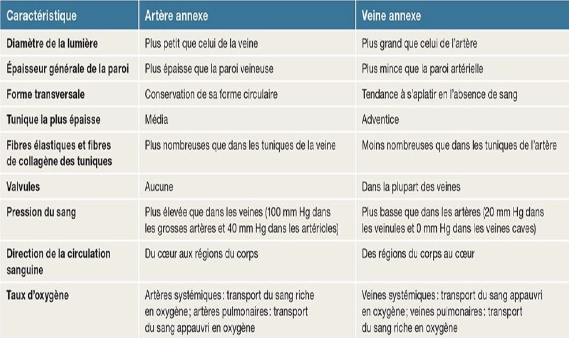

This text is underlined

**This text is bold**

*This text is in italic*

This text is in orange

This is a list:

* Item 1
* Item 2
* Item 3
* Item 4
* Item 5

This is an equation:

$${\left(x+a\right)}^{n}=\sum_{k=0}^{n}{\left({n \atop k}\right)x^{k}a^{n-k}}$$

This is another image (should be an .emf file):



This is a table :

|  |  |  |  |  |  |
| --- | --- | --- | --- | --- | --- |
| 1 | 2 | 3 | 4 | 5 | 6 |
| a | a | a | a | a | a |
| b | b | b | b | b | b |
| c | c | c | c | c | c |
| d | d | d | d | d | d |
| e | e | e | e | e | e |